**Exercise 1 : Configuring a Basic Spring Application**

Created a web application for managing a library using Spring Framework to handle the backend operations called LibraryManagement.

The pom.xml file contains all Spring Core dependencies.

In the applicationContext.xml in the src/main/resources directory BookService and BookRepository beans are defined.

**Exercise 2 : Implementing Dependency Injection**

Ioc(Inversion of control) and DI(Dependency Injection) are added to maintain and control beans(objects)

Added getter and setter methods in BookService and BookRepository

**Output after dependency Injection**

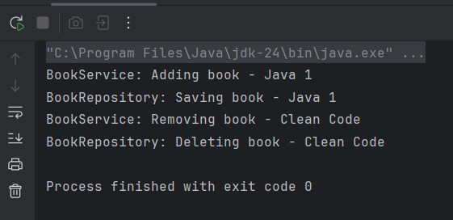

**Exercise 3: Implementing Logging with Spring AOP**

Added AOP dependencies in pm.xml for logging the method LoggingAspect in the package com.library.aspect logs the execution time.

**Output after implementing Logging**

